Inventory App Methodology

# Bootstrap six default breakpoints

This is an interesting implementation off CSS where the smallest screen gets priority first then moves up to larger screen rather than the reverse which is what most web developers would do. This makes some sense since you can go below 0 pixels for a screen but can go above 1400px the maximum breakpoint.

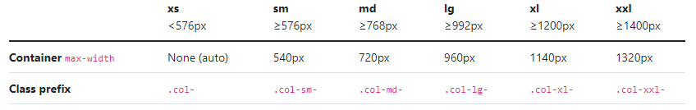

The class prefix will work for most Bootstrap classes and the rule of thumb is if it has more than on options or a number then the six breakpoints can be applied.

# Grid

Grid is the most commonly used thing is